Kubernetes Task -06

Overall Task Title
Kubernetes Configuration Management Using ConfigMaps and Secrets
Objective
To demonstrate how Kubernetes ConfigMaps and Secrets are used to externalize application configuration. This includes creating ConfigMaps from directories and files, injecting configuration data into pods as environment variables, mounting configuration as volumes, securely managing sensitive data using Secrets, and combining both ConfigMaps and Secrets within a single pod.
Prerequisites
• A running Kubernetes cluster (Minikube / Kubeadm / Cloud cluster)
• kubectl installed and configured
• Basic understanding of Pods, ConfigMaps, and Secrets
• A container image for testing (e.g., nginx)
• Access to terminal/CLI with cluster permissions
Conclusion
This exercise validates the practical use of ConfigMaps and Secrets for managing application configuration in Kubernetes. ConfigMaps enable flexible, decoupled configuration management, while Secrets provide a secure mechanism for handling sensitive data. By injecting data as environment variables and mounting it as files, Kubernetes supports multiple configuration patterns. Combining both resources within the same pod illustrates real-world deployment scenarios where applications require both standard configuration and protected credentials.

- Create a ConfigMap from a directory containing multiple files and inject the variables into a pod as environment variables.
Steps Performed:
• Created a directory to store configuration files
mkdir app-config
Environment Files Creation
• Created the first environment file
echo 'DB_HOST=localhost' > app-config/db.env
• Created the second environment file
echo 'APP_MODE=production' > app-config/app.env
ConfigMap Creation
• Generated a ConfigMap from the directory
kubectl create configmap app-config --from-file=app-config/
ConfigMap Verification
• Verified that the ConfigMap was created
kubectl get cm
• Inspected the ConfigMap contents
kubectl get configmap app-config -o yaml
Pod Definition
• Created a Pod definition referencing the ConfigMap
apiVersion: v1
kind: Pod
metadata:
name: configmap-env-pod
spec:
containers:
- name: nginx
image: nginx
envFrom:
- configMapRef:
name: app-config
Pod Deployment
• Applied the Pod configuration
kubectl apply -f pod.yaml
Environment Variables Validation
• Verified environment variables inside the Pod
kubectl exec -it configmap-env-pod -- printenv
• Confirmed variables were injected successfully
(APP_MODE and DB_HOST visible in output)
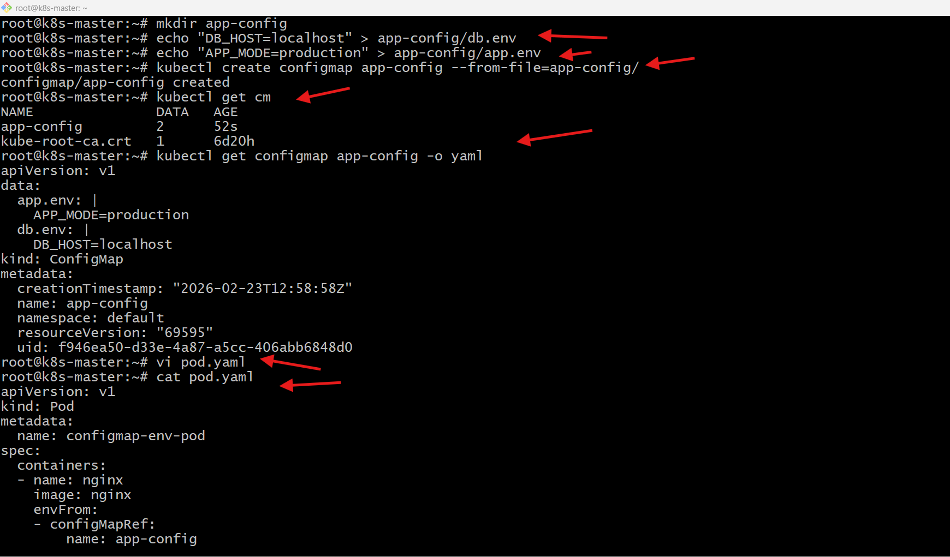
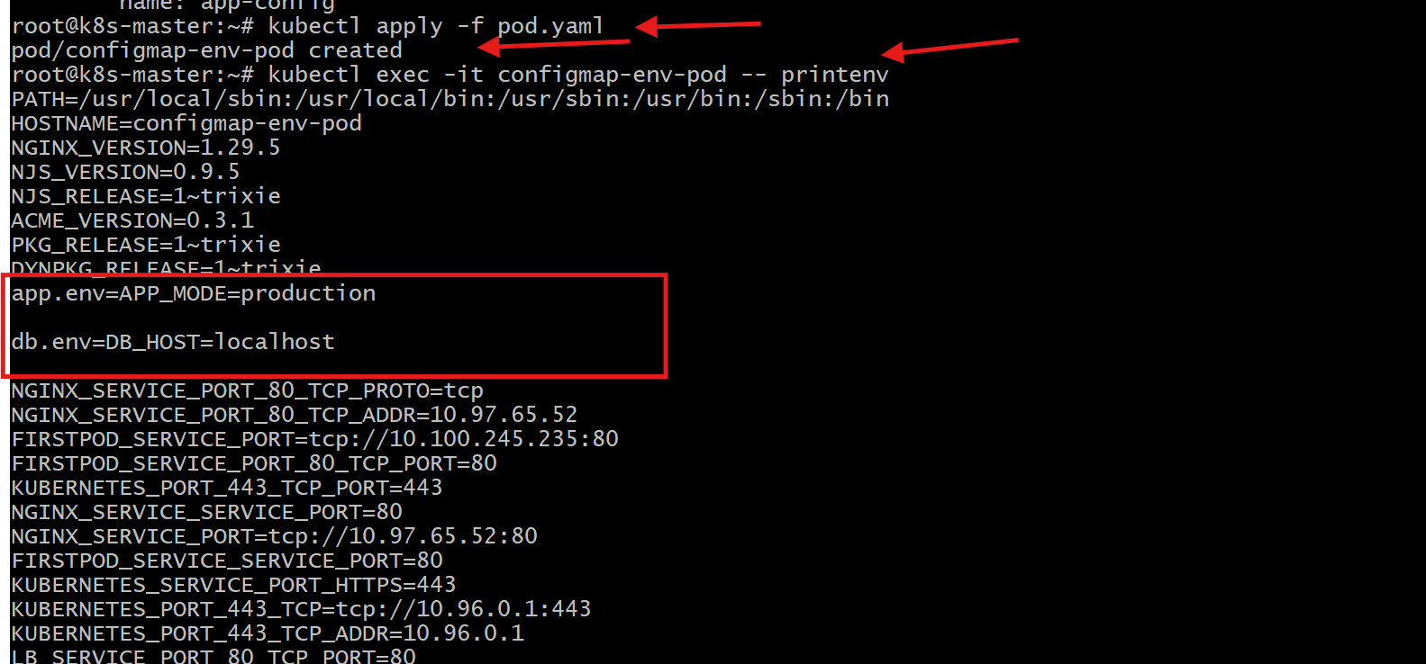

- Create a ConfigMap from a file and mount it as a volume inside a pod, ensuring the configuration data is available as files.
Steps Performed:
• Created a configuration file
echo 'server_port=8080' > app.properties
• Verified file contents
cat app.properties
ConfigMap Creation
• Created a ConfigMap from the file
kubectl create configmap app-file-config --from-file=app.properties
Pod Definition
• Created a Pod YAML mounting the ConfigMap as a volume
apiVersion: v1
kind: Pod
metadata:
name: configmap-volume-pod
spec:
containers:
- name: nginx
image: nginx
volumeMounts:
- name: config-volume
mountPath: /etc/config
volumes:
- name: config-volume
configMap:
name: app-file-config
Pod Deployment
• Applied the Pod configuration
kubectl apply -f pod.yaml
Volume Validation
• Listed mounted files inside the Pod
kubectl exec -it configmap-volume-pod -- ls /etc/config
• Verified file contents inside the Pod
kubectl exec -it configmap-volume-pod -- cat /etc/config/app.properties
• Confirmed configuration file is available with expected data
server_port=8080
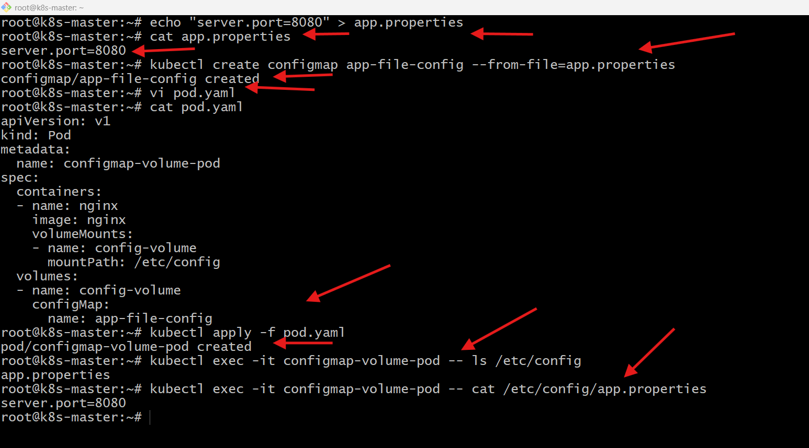
3.Create a Secret with sensitive information (username and password) and inject it into a pod as environment variables.
Steps Performed:
• Created a Secret with sensitive values
kubectl create secret generic db-secret --from-literal=username=admin --from-literal=password=MyStrongPass123
Secret Verification
• Verified Secret details
kubectl get secret db-secret -o yaml
Pod Definition
• Created a Pod YAML referencing the Secret as environment variables
apiVersion: v1
kind: Pod
metadata:
name: secret-env-pod
spec:
containers:
- name: nginx
image: nginx
env:
- name: DB_USER
valueFrom:
secretKeyRef:
name: db-secret
key: username
- name: DB_PASS
valueFrom:
secretKeyRef:
name: db-secret
key: password
Pod Deployment
• Applied the Pod configuration
kubectl apply -f pod.yaml
Environment Variables Validation
• Verified Secret values inside the Pod
kubectl exec -it secret-env-pod -- printenv | grep DB
• Confirmed Secret variables were injected successfully
DB_USER and DB_PASS visible in output
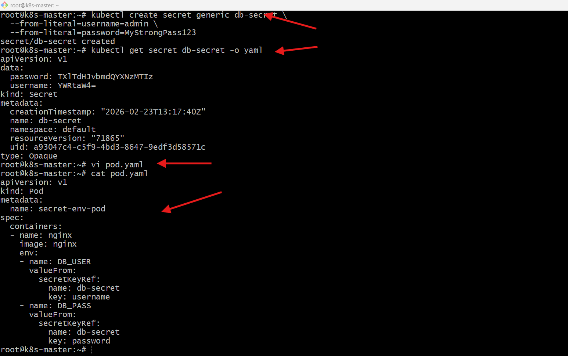
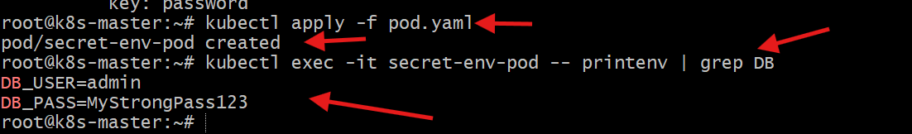

4.Create a Secret using a YAML file, mount it as a volume in a pod, and verify the specific Secret values are available as files.
Steps Performed:
• Encoded username value
echo -n 'admin' | base64
• Encoded password value
echo -n 'MyStrongPass123' | base64
Secret YAML Creation
• Created Secret definition file
apiVersion: v1
kind: Secret
metadata:
name: yaml-secret
type: Opaque
data:
username: YWRtaW4=
password: TXlTdHJvbmdQYXNzMTIz
Secret Deployment
• Applied the Secret configuration
kubectl apply -f secret.yaml
Secret Verification
• Verified Secret creation
kubectl get secret
Pod Definition
• Created Pod YAML mounting the Secret as a volume
apiVersion: v1
kind: Pod
metadata:
name: secret-volume-pod
spec:
containers:
- name: nginx
image: nginx
volumeMounts:
- name: secret-volume
mountPath: /etc/secret
readOnly: true
volumes:
- name: secret-volume
secret:
secretName: yaml-secret
Pod Deployment
• Applied the Pod configuration
kubectl apply -f pod.yaml
Secret Volume Validation
• Listed Secret files inside the Pod
kubectl exec -it secret-volume-pod -- ls /etc/secret
• Verified Secret values as files
kubectl exec -it secret-volume-pod -- cat /etc/secret/username
kubectl exec -it secret-volume-pod -- cat /etc/secret/password
• Confirmed Secret data is correctly mounted and accessible as files
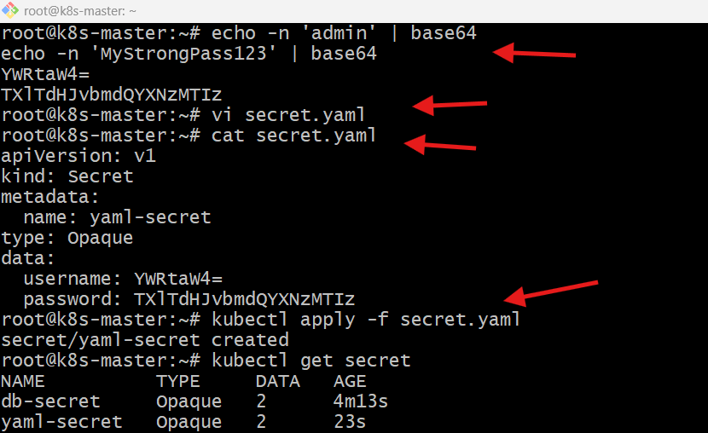
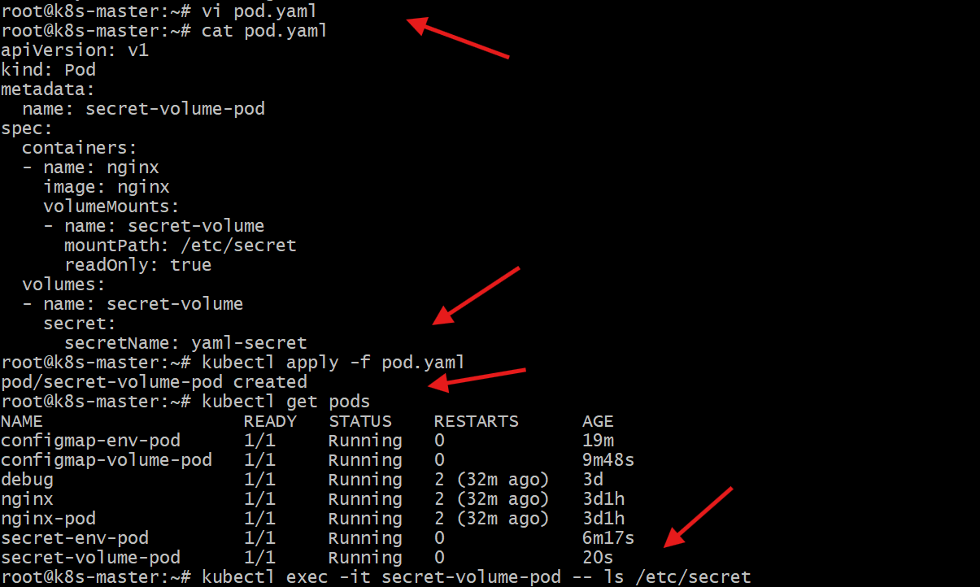

5.Inject a ConfigMap as environment variables and a Secret as files into the same pod, ensuring both are accessible within the pod.
Steps Performed:
• Created a Pod definition combining ConfigMap and Secret
apiVersion: v1
kind: Pod
metadata:
name: combined-pod
spec:
containers:
- name: nginx
image: nginx
envFrom:
- configMapRef:
name: app-config
volumeMounts:
- name: secret-volume
mountPath: /etc/secret
readOnly: true
volumes:
- name: secret-volume
secret:
secretName: yaml-secret
Pod Deployment
• Applied the Pod configuration
kubectl apply -f combined.yaml
ConfigMap Validation (Environment Variables)
• Verified injected environment variables
kubectl exec -it combined-pod -- printenv
• Confirmed ConfigMap values are available
(APP_MODE, DB_HOST visible in output)
Secret Validation (Mounted Files)
• Listed Secret files inside the Pod
kubectl exec -it combined-pod -- ls /etc/secret
• Confirmed Secret keys are mounted as files
(username and password present)
• Verified Secret values
kubectl exec -it combined-pod -- cat /etc/secret/username
kubectl exec -it combined-pod -- cat /etc/secret/password
• Confirmed both ConfigMap and Secret are accessible within the same Pod
